# Subscriber’s Galore : Exploring world’s top youtube channels

# 1 INTRODUCTION

* 1. Overview

A subscriber to a channel on the video-sharing YouTube is a usto receive the channel's content by clicking on that channel's "Subscribe" button,and each user's subscription feed consists of videos published by channels to which the user is subscribed. The ability to subscribe to users was introduced in October 2005. YouTube began publishing a list of its most- subscribed channels in April 2006. An early archive of the list dates to May 2006. The following table lists the 50 most-subscribed YouTube channels, as well as the primary language and content category of each channel.

* 1. Purpose

Channel Information: Each YouTube channel should have a dedicated page or profile that displays essential information, including the channel name, description, subscriber count, video views, upload frequency, and engagement metrics.

Subscription Management: Users should have the ability to subscribe to their favorite YouTube channels within the platform, allowing them to receive notifications about new uploads and updates from those channels.

Analytics and Insights: The platform should provide analytics and insights to track user engagement, popular channels, and trending content. This data can be used to improve content curation, personalize recommendations, and enhance the overall user experience.

These business requirements aim to create a user-friendly platform that facilitates the exploration and discovery of YouTube channels, while also providing features for personalization, social interaction, and monetization. By meeting these requirements, the platform can enhance user engagement and satisfaction, while also creating opportunities for revenue generation and growth.

**2 Problem Definition & Design Thinking**

**Define Problem / Problem Understanding**

**● Specify the business problem ● Business requirements**

**● Literature Survey**

**● Social or Business Impact.**

2.1 Empathy Map

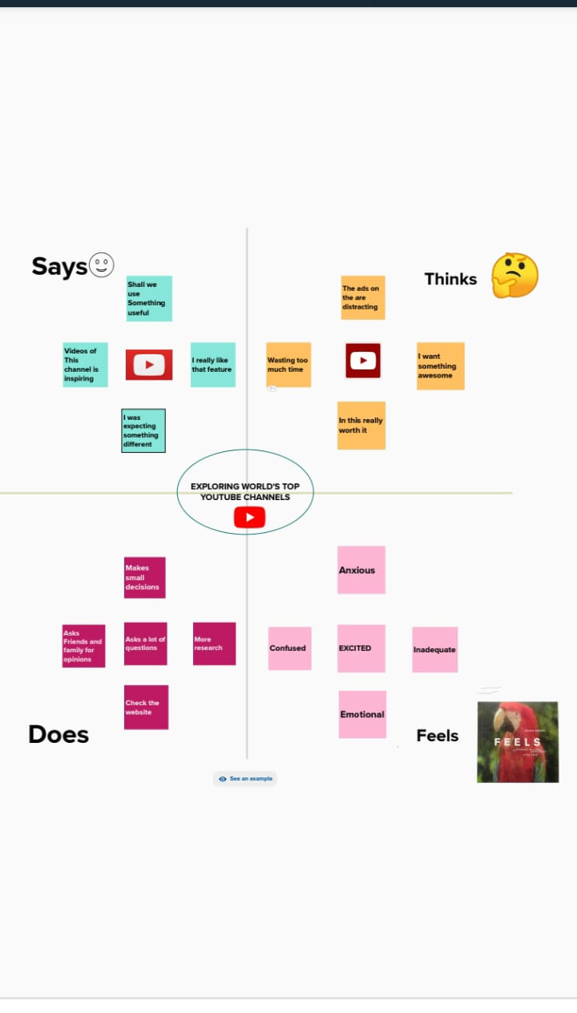

## 2.2 Ideation & Brainstorming Map

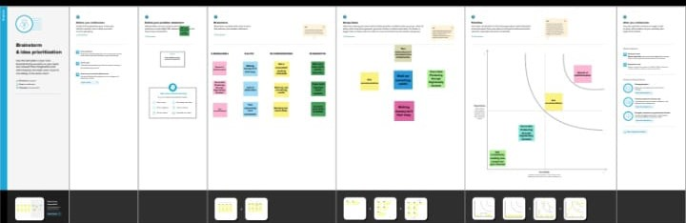

# 

# 3. RESULT

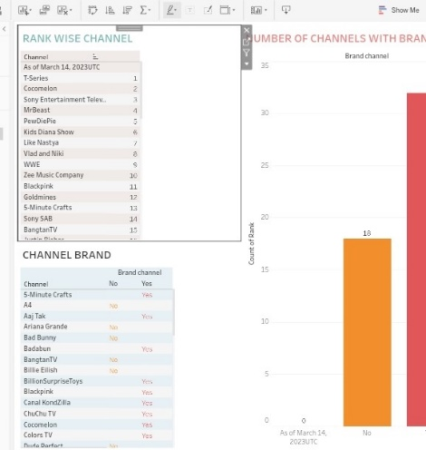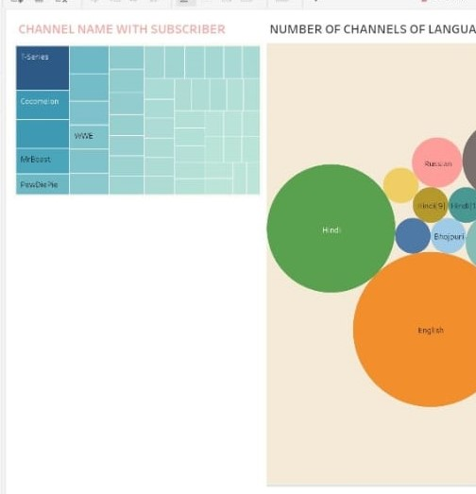

# 4 ADVANTAGES & DISADVANTAGES

1. Financial Perspective

2. Customer Perspective

3. Internal Process Perspective

4. Learning and Growth Perspective

# 5 APPLICATIONS

# A dashboard is a graphical user interface (GUI) that displays information and data in an organized, easy-to-read format. Dashboards are often used to provide realtime monitoring and analysis of data, and are typically designed for a specific purpose or use case. Dashboards can be used in a variety of settings, such as business, finance, manufacturing, healthcare, and many other industries. They can be used to track key performance indicators (KPIs), monitor performance metrics, and display data in the form of charts, graphs, and tables.

# 6 CONCLUSION

The responsiveness and design of a dashboard for Data-Driven insights on YouTube channels Analysis is crucial to ensure that the information is easily understandable and actionable. Key considerations for designing a responsive and effective dashboard include user-centered design, clear and concise information, interactivity, data-driven approach, accessibility, customization, and security. The goal is to create a dashboard that is user-friendly, interactive, and data-driven, providing actionable insights.

# 7 FUTURE SCOPE

# The number of scenes in a storyboard for Data-Driven insights on YouTube channels Analysis will depend on the complexity of the analysis and the specific insights that are trying to be conveyed. A storyboard is a visual representation of the data analysis process and it breaks down the analysis into a series of steps or scenes

# 8 APPENDIX

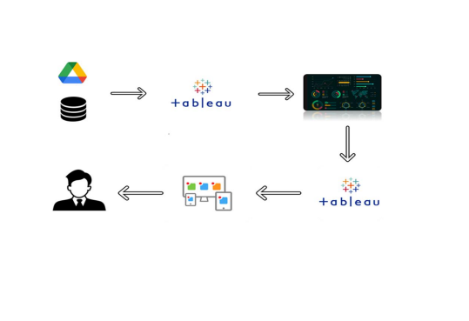

# Project Report Template